**DAILY ONLINE ACTIVITIES SUMMARY**

|  |  |  |  |  |  |  |  |
| --- | --- | --- | --- | --- | --- | --- | --- |
| **Date:** | **31/05/2020** | | | | **Name:** | **Samrin banu** | |
| **Sem & Sec** | **8th B** | | | | **USN:** | **4AL16CS082** | |
| Online Test Summary | | | | | | | |
| **Subject** | | **Iot** | | | | | |
| **Max. Marks** | | **20** | | **Score** | | **19** | |
| Certification Course Summary | | | | | | | |
| **Course** | **Step into Robotic Process Automation** | | | | | | |
| **Certificate Provider** | | | **Guvi** | **Duration** | | | **3 hrs** |
| Coding Challenges | | | | | | | |
| **Problem Statement:**  **1)C progam to print right angled traigle numbers star pattern.** | | | | | | | |
| **Status: Solved** | | | | | | | |
| **Uploaded the report in Github** | | | | **YES** | | | |
| **If yes Repository name** | | | | **Samrinbanu** | | | |
| **Uploaded the report in slack** | | | | **YES** | | | |

**Online Test Details**:

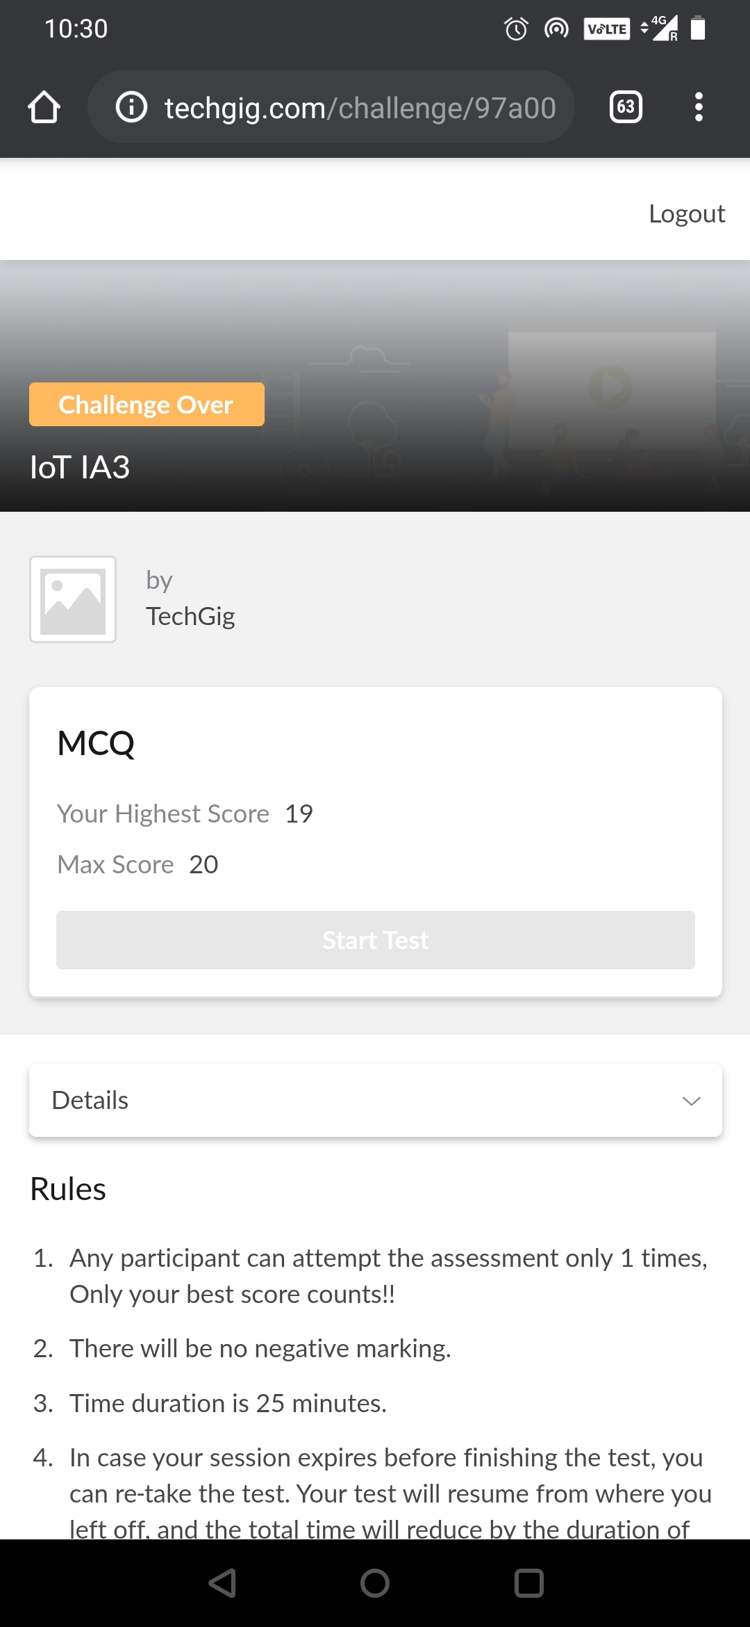

**Certification Course Details:**



# CODE:

Program no:1

### **C progam to print right angled traigle numbers star pattern**###

int main()

{

int Rows, i, j;

printf("Please Enter the Number of Rows: ");

scanf("%d", &Rows);

printf("\nPrinting Right Angled Triangle \n \n");

for ( i = 1 ; i <= Rows; i++ )

{

for ( j = 1 ; j <= i; j++ )

{

printf("* ");

}

printf("\n");

}

return 0;

}